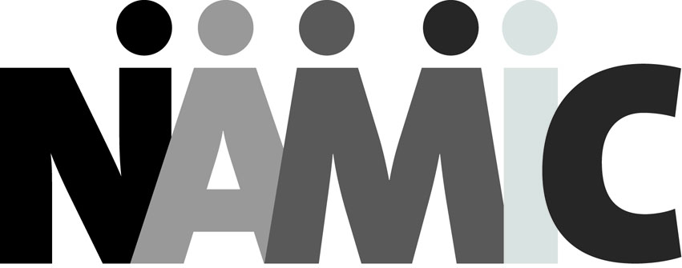
NATIONAL ASSOCIATION FOR MULTI-ETHNICITY IN COMMUNICATIONS
30th ANNUAL NAMIC CONFERENCE

REGULAR REGISTRATION FORM

Register me for the 30th Annual NAMIC Conference as follows:
□$725 – Single Day Rate for Tuesday, September 20
□$525 – Single Day Rate for Wednesday, September 21

Name
Title
Company
Address
City/State/Zip Code
Phone Number
FAX Number
Email (required)

PAYMENT: □Check (made payable to NAMIC, Inc.) □Credit Card
I authorize NAMIC to charge $_______________ to my: □American Express □Discover
□Master Card □Visa

Signature
Name on Credit Card
Card Number
Expiration Date
Authorization Code
Billing Address (if different than above)
City/State/Zip Code

Checks should be made out to NAMIC Inc. and mailed to: NAMIC, 50 Broad Street, Suite 1801, New York, NY 10004

Email completed form to: Sandra Girado, Vice President, Events and Partner Relations at sandra.girado@namic.com

